The Sequoia office building in Nové Roztyly enters the next stage of construction
The Sequoia office building, which is being built as part of the development of Nové Roztyly in Prague 11, has reached another significant milestone. Following the completion of the construction pit, the foundation slab has also been successfully completed, permanently defining the building’s substructure ground plan and enabling the continuation of the construction of the underground and then the above-ground floors. The project is technically challenging not only because of its size, but also due to its location on sloping terrain with an elevation difference of up to 13 metres and foundations below the groundwater level. The project is being carried out by Passerinvest Group and the GEMO Group, which is also acting as the project's general contractor. The Sequoia building is scheduled for completion in the first half of 2028.
“The completion of the foundation slab is one of the most important milestones in the whole construction. It is during this phase that the building takes on its final footprint and work on the individual floors can begin. Sequoia is being built under challenging geological and terrain conditions and that’s why, from the beginning, we have emphasised high-quality technical solutions for the building’s foundation and its long-term durability. We are delighted that all the work is going according to schedule and the project is moving on to the next stage,” said Martin Unger, Technical Director & ESG, Passerinvest Group.
Sequoia as part of the transformation of Nové Roztyly
Sequoia is another step and a key component in the transformation of the Nové Roztyly area where Passerinvest Group is gradually creating a modern urban district that combines office buildings, public spaces, services, greenery and future residential development, on which the greatest emphasis is being placed and will continue to be placed. The project follows on from the already completed Roztyly Plaza building and further develops the area around Roztyly metro station and Krč Forest.
Upon completion, the Sequoia building will offer more than 33,000 sqm of state-of-the-art office space, a canteen and café, shared conference rooms for up to 200 people, a rooftop terrace with greenery, private balconies and facilities for cyclists. The underground levels will provide tenants with 488 parking spaces, some of which will be equipped with charging stations for electric vehicles.
There is a comprehensive approach to sustainability included in the Sequoia project. The building will use heat pumps, photovoltaic panels and energy-efficient heating and cooling systems. There is also a lot of emphasis on the quality of the indoor environment, ample fresh air, water management – including the implementation of blue-green infrastructure measures and support for biodiversity around the building. The project will achieve the highest level of environmental certification, BREEAM Outstanding.
What Sequoia will offer:
- 33,000 sqm of office space and 375 sqm of retail space
- up to 3,500 sqm of office space on one floor
- 755 sqm of rooftop gardens and private balconies
- 488 parking spaces in underground garages, some equipped with electric charging stations
- 11 office floors
- visibility from Prague’s busiest thoroughfares – the 5. května trunk road and the Jižní spojka/city ring road
- low operating costs
- new direct access to the building from the Jižní spojka
- a canteen with café, a rooftop terrace with greenery, and private balconies with views of Krč Forest
- shared conference rooms for up to 200 people
- BREEAM Outstanding certification
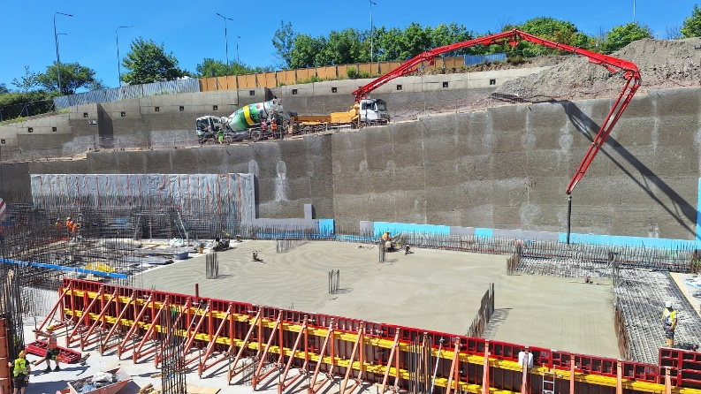
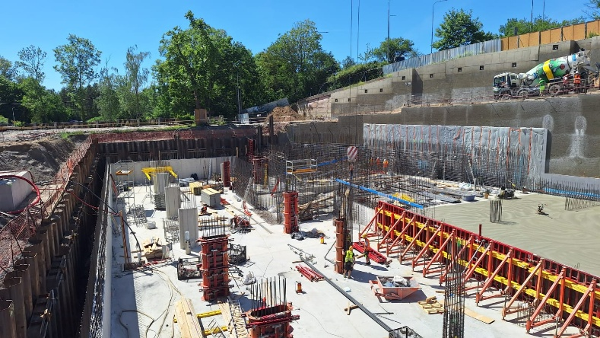
- completion of the project in the first half of 2028

In the photos: A current view of the ongoing construction of the Sequoia office building in Prague’s Roztyly district.
Challenging foundation work below the groundwater level
Earthwork on the construction pit took place between September 2025 and April 2026 and during those eight months more than 66,000 m³ of soil was excavated from the site. The earthwork and pit stabilisation were followed by the construction of the foundation slab, which took approximately two and a half months. The foundation slab itself has an area of almost 5,800 sqm and a thickness of 750 mm. Its construction required around 4,500 m³ of concrete and 720 tons of steel reinforcement.
The structure is supported by 219 piles with diameters of between 900 to 1,500 mm, with a total length reaching almost 1.6 kilometres. The substructure is designed with an emphasis on long-term resistance to groundwater and other environmental factors. Protection against water ingress is secured by a “white tank” system using hydraulic concrete and special sealing elements. The technical solution also includes protection against stray earth currents, which contributes to the long-term durability of the reinforced concrete structures.

Sequoia project website: NoveRoztyly.cz

More information and print-quality photographs can be provided by:
Kristýna Samková, Head of the PR and Marketing Department
PASSERINVEST GROUP, a.s.
Tel.: (+420) 221 582 111
E-mail: Kristyna.Samkova@Passerinvest.cz
www.passerinvest.cz, www.brumlovka.cz

Kamila Žitňáková
Crest Communications a.s.
Mobile: (+420) 725 544 106
E-mail: kamila.zitnakova@crestcom.cz

About the company:
Passerinvest Group (Passerinvest) is a 100% Czech builder and investor. The company was founded by Radim Passer in 1991 and since then it has gained a wealth of experience in the construction of office and commercial buildings, residential properties and civic amenities. As a responsible urban developer, since 1998 Passerinvest has been mainly associated with Brumlovka in Prague 4, which is one of the largest and most successful urban projects not only in the Czech Republic, but in the whole of Europe. In 2025, Brumlovka became the only location of its kind to receive the prestigious Fitwel certification with the highest Three Star rating, the first and only one in the EU to do so. Another major project in the company’s portfolio is Nové Roztyly (roztylyplaza.cz), specifically the brownfield of the former Interlov slaughterhouse where in the future a site with pleasant housing and a large park, including additional services for the general public and offices, is to be created. The principles of urban construction and the long-term sustainable development of Prague and the Czech Republic are part of the vision of Passerinvest, which has built an excellent name for itself both domestically and internationally thanks to its responsible approach. This is due not only to the quality of the projects carried out and the high standards of the services provided, but also its sense of fair play, its customer approach and, above all, its responsibility towards society and the environment.

